## UNIT - IV

**STATE SPACE ANALYSIS OF CONTINUOUS SYSTEMS**

The **state space model** of Linear Time-Invariant (LTI) system can be represented as,

X˙=AX+BU Y=CX+DU

The first and the second equations are known as state equation and output equation respectively.

Where,

* + X and X˙ are the state vector and the differential state vector respectively.
  + U and Y are input vector and output vector respectively.
  + A is the system matrix.
  + B and C are the input and the output matrices.
  + D is the feed-forward matrix.

## Basic Concepts of State Space Model

The following basic terminology involved in this chapter.

## State

It is a group of variables, which summarizes the history of the system in order to predict the future values (outputs).

## State Variable

The number of the state variables required is equal to the number of the storage elements present in the system.

**Examples** − current flowing through inductor, voltage across capacitor State Vector

It is a vector, which contains the state variables as elements.

In the earlier chapters, we have discussed two mathematical models of the control systems. Those are the differential equation model and the transfer function model. The state space model can be obtained from any one of these two mathematical models. Let us now discuss these two methods one by one.

## State Space Model from Differential Equation

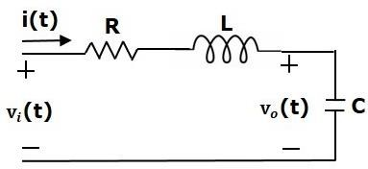Consider the following series of the RLC circuit. It is having an input voltage, vi(t) and the current flowing through the circuit is i(t).

There are two storage elements (inductor and capacitor) in this circuit. So, the number of the state variables is equal to two and these state variables are the current flowing through the inductor, i(t) and the voltage across capacitor, vc(t).

From the circuit, the output voltage, v0(t) is equal to the voltage across capacitor, vc(t).

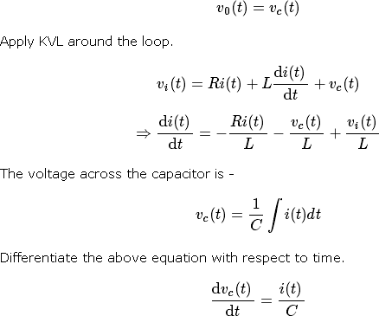

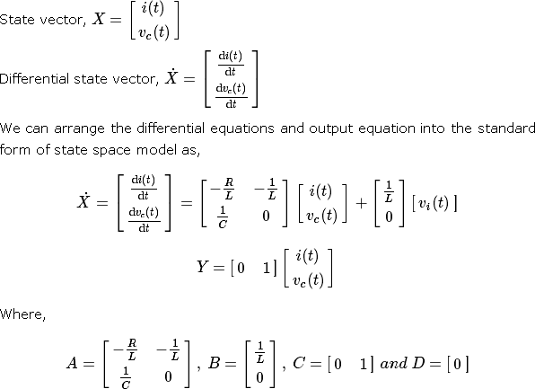

## State Space Model from Transfer Function

Consider the two types of transfer functions based on the type of terms present in the numerator.

* + Transfer function having constant term in Numerator.
  + Transfer function having polynomial function of ‘s’ in Numerator. Transfer function having constant term in Numerator

Consider the following transfer function of a system

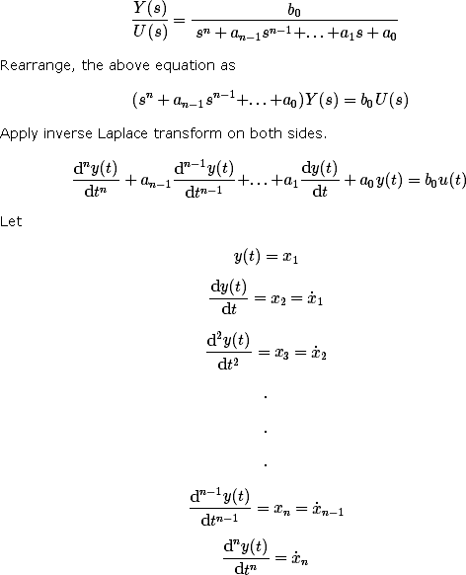

and u(t)=u

Then,

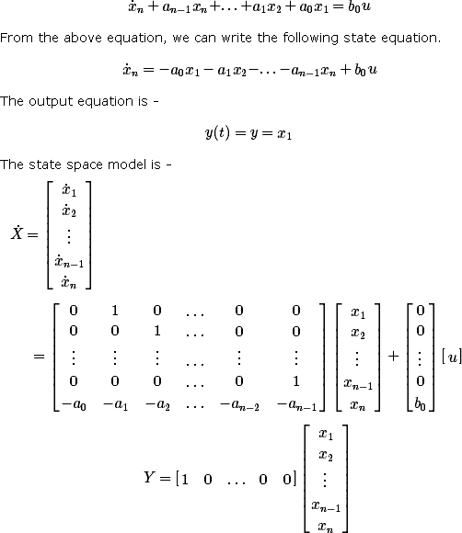

Here, D=[0].

Example

Find the state space model for the system having transfer function.

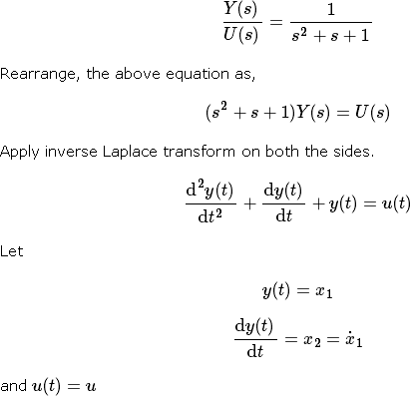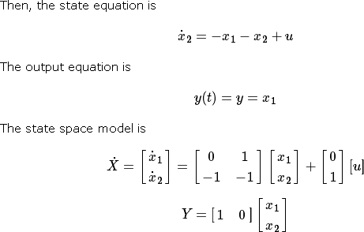

Transfer function having polynomial function of ‘s’ in Numerator Consider the following transfer function of a system

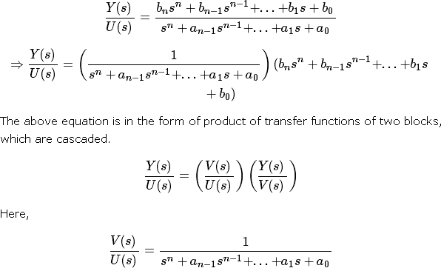

Rearrange, the above equation as

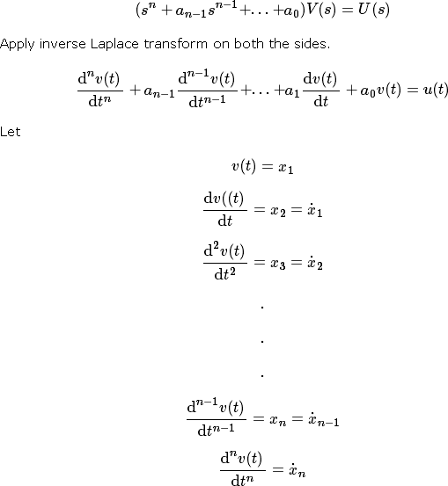

and u(t)=u

Then, the state equation is

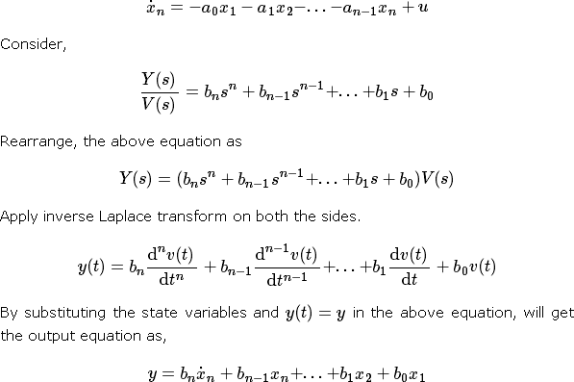

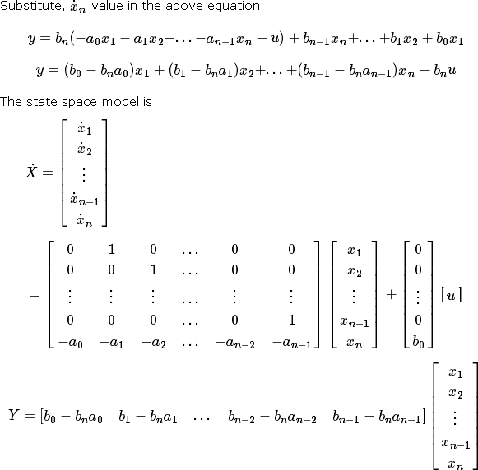

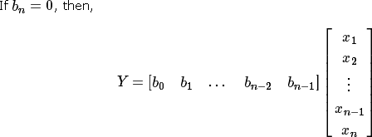

Transfer Function from State Space Model

We know the state space model of a Linear Time-Invariant (LTI) system is -

X˙=AX+BU Y=CX+DU

Apply Laplace Transform on both sides of the state equation.

sX(s) =AX(s)+BU(s)

⇒ (sI−A)X(s)=BU(s)

⇒ X(s) = (sI−A)−1BU(s)

Apply Laplace Transform on both sides of the output equation.

Y(s) =CX(s) + DU(s)

Substitute, X(s) value in the above equation.

⇒Y(s) =C ( sI−A)−1BU(s)+DU(s)

⇒Y(s) = [C (sI−A)−1B+D]U(s)

⇒Y(s) U(s) = C(sI−A)−1 B+D

The above equation represents the transfer function of the system. So, we can calculate the transfer function of the system by using this formula for the system represented in the state space model.

**Note** − When D=[0], the transfer function will be

## Example

Let us calculate the transfer function of the system represented in the state space model as,

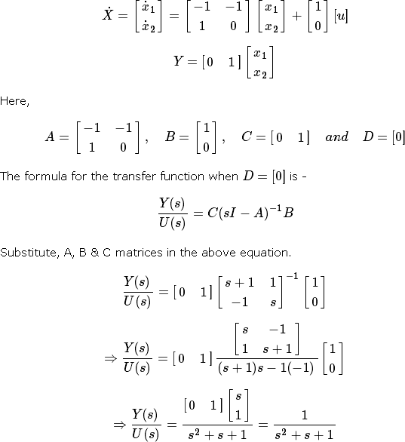

Therefore, the transfer function of the system for the given state space model is



State Transition Matrix and its Properties

If the system is having initial conditions, then it will produce an output. Since, this output is present even in the absence of input, it is called **zero input response** xZIR(t). Mathematically, we can write it as,



From the above relation, we can write the state transition matrix ϕ(t) as



So, the zero input response can be obtained by multiplying the state transition matrix ϕ(t) with the initial conditions matrix.

## Properties of the state transition matrix

* + If t=0, then state transition matrix will be equal to an Identity matrix.

ϕ(0)=I

* + Inverse of state transition matrix will be same as that of state transition matrix just by replacing ‘t’ by ‘-t’.
  + If t=t1+t2 , then the corresponding state transition matrix is equal to the multiplication of the two state transition matrices at t=t1t=t1 and t=t2t=t2.

ϕ(t1+t2)=ϕ(t1)ϕ(t2)

Controllability and Observability

Let us now discuss controllability and observability of control system one by one. Controllability

A control system is said to be **controllable** if the initial states of the control system are

transferred (changed) to some other desired states by a controlled input in finite duration of time.

We can check the controllability of a control system by using **Kalman’s test**.

* + Write the matrix Qc in the following form.



* + Find the determinant of matrix QcQc and if it is not equal to zero, then the control system is controllable.

Observability

A control system is said to be **observable** if it is able to determine the initial states of the control system by observing the outputs in finite duration of time.

We can check the observability of a control system by using **Kalman’s test**.

* + Write the matrix Qo in following form.



* + Find the determinant of matrix QoQo and if it is not equal to zero, then the control system is observable.

## Example

Let us verify the controllability and observability of a control system which is represented in the state space model as,

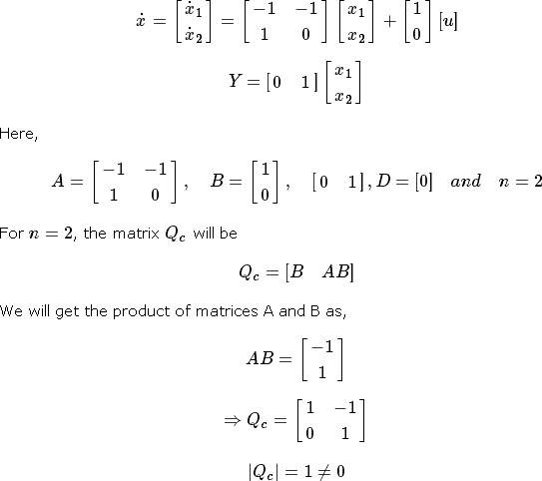

Since the determinant of matrix Qc is not equal to zero, the given control system is controllable.

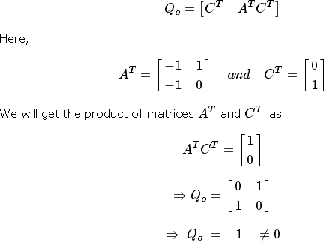For n=2, the matrix Qo will be –

Since, the determinant of matrix Qo is not equal to zero, the given control system is observable.Therefore, the given control system is both controllable and observable.